Brandon Tenorio

Fall 2021

MATH280

Professor Camilo Diaz

***Project 1***

***Handwritten work***

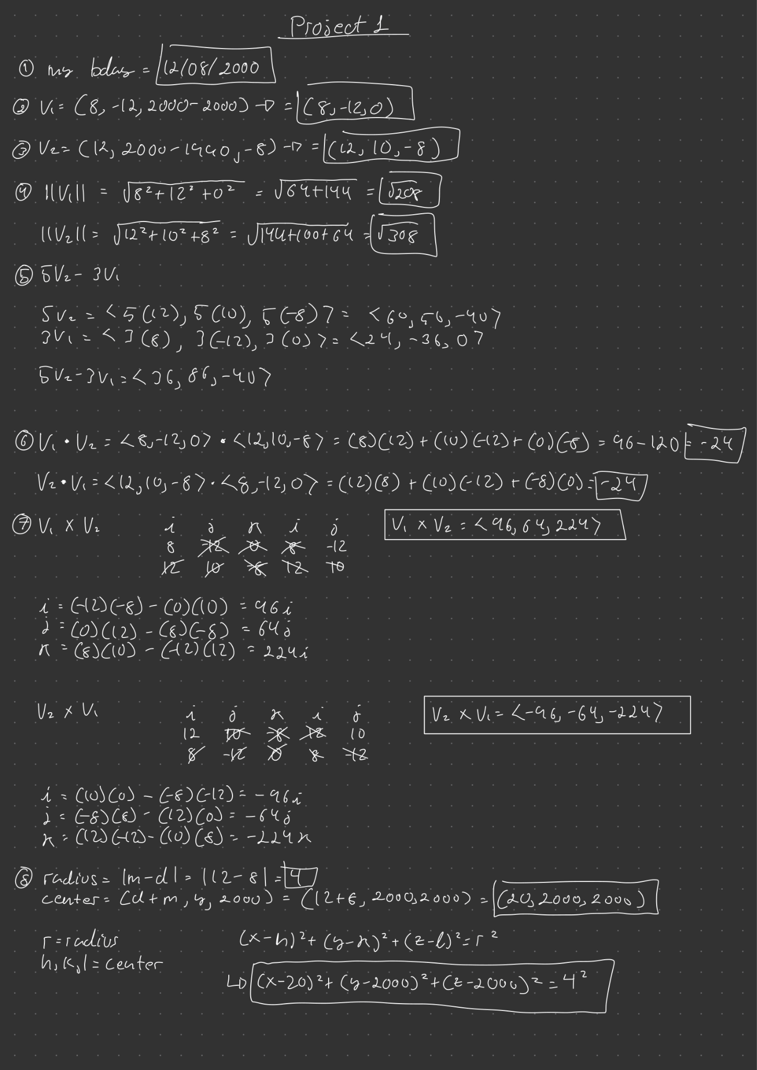

***Matlab Code***

clc

clear

clear all

[x,y,z] = sphere; %the sphere

v1 = [8 -12 0];

v2 = [12 10 -8];

dot(v1,v2);

cross(v1,v2);

cross(v2,v1);

5*v2-3*v1

x = x*20;

y = y*2000;

z = z*2000;

r = 4;

surf(r*x+20, r*y+2000, r*z+2000);

***Matlab Screenshot***

